**AIM**

Write a C program to implement Array operations such as Insert, Delete and Display

**ALGORITHM:**

• Start the program.

• Declare an array and variables to track its size.

• Provide a menu with choices:

* **Insert**: Read position and element, shift elements to the right, and insert.
* **Delete**: Read position, shift elements to the left, and reduce size.
* **Display**: Print the array elements.

• Repeat until the user exits.

• End the program.

**CODE:**

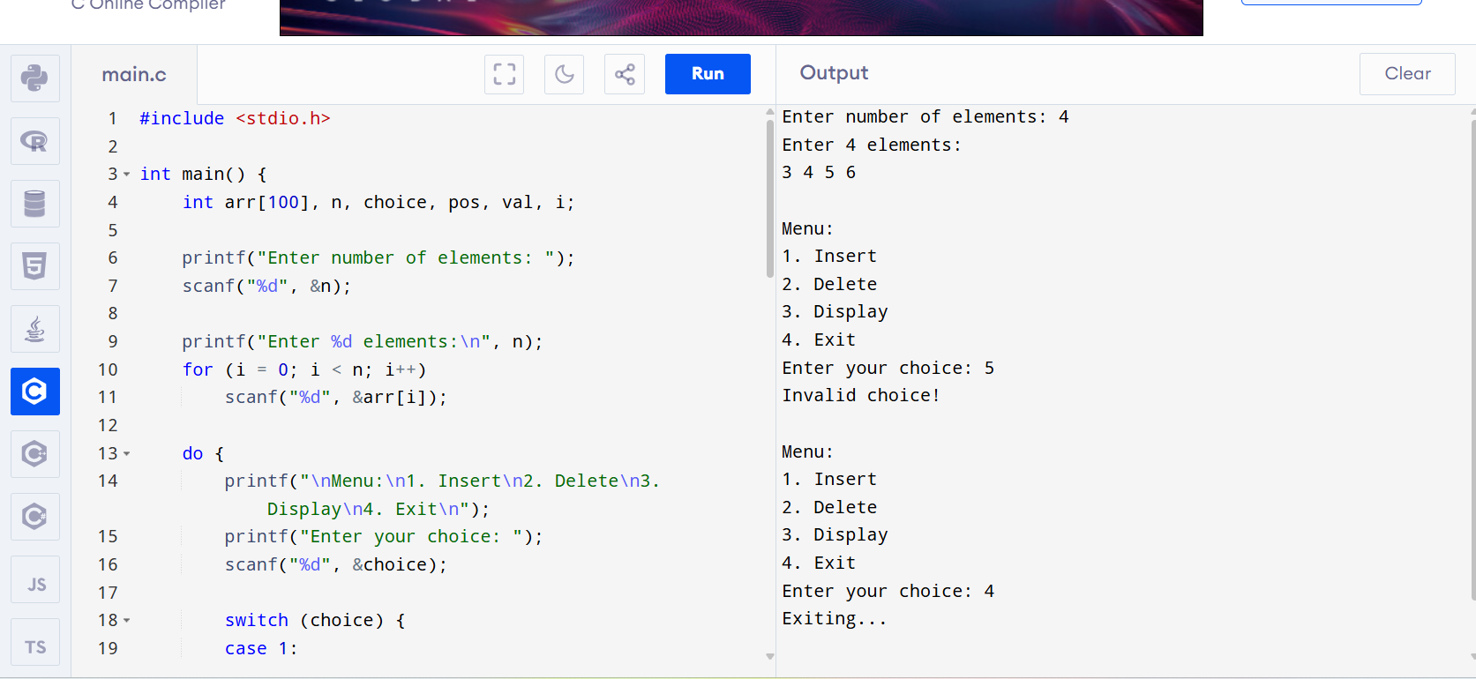

OUTPUT:

Enter number of elements: 5

Enter 5 elements:

4 5 6 7 8

Menu:

1. Insert

2. Delete

3. Display

4. Exit

Enter your choice: 6

Invalid choice!

Menu:

1. Insert

2. Delete

3. Display

4. Exit

Enter your choice: 4

Exiting...